PAST MEDICAL HISTORY FORM

Patient Name: Date:

Date of injury / onset: / / Have you ever had Physical Therapy for these symptoms before?   Yes   No

Check which apply to your symptoms:

  work related injury |   recurrence of previous injury
  motor vehicle accident |   injury related to lifting |   injury related to falling
  cause unknown |   athletic / recreational injury |   other:

Have you had a related surgery?
Yes
No If YES, date of surgery: / /

What are some of yours goals and expectations with Physical Therapy?
 
 

Are you currently working?
  Yes
  No

Do you have, or have you had any of the following?
 | Yes | No |  | Yes | No
Diabetes |   |   | Allergies to Aspirin |   |  
Chest / Angina |   |   | Allergies to Heat |   |  
High Blood Pressure |   |   | Allergies / Poor tolerance to Cold |   |  
Heart Disease |   |   | Other Allergies |   |  
Heart Attack |   |   | Hernia |   |  
Heart Palpitations |   |   | Seizures |   |  
Pacemaker |   |   | Metal Implants |   |    
Headaches |   |   | Dizziness / Fainting |   |    
Kidney Problems |   |   | Recent Fracture |   |  
Are you pregnant? |   |   | Surgeries |   |  
Cancer |   |   | Skin Abnormalities |   |  
Osteoporosis |   |   | Sexual Dysfunction |   |  
Bowel / Bladder Abnormalities |   |   | Nausea/ Vomiting |   |  
Urine Leakage |   |   | Ringing in your ears |   |  
Asthma / Breathing Difficulties |   |   | Rheumatoid Arthritis |   |  
Liver / Gallbladder Problems |   |   | Special Diet Guidelines |   |  
Smoking |   |   | Hypoglycemia |   |  
Other: |   |   | Stroke/CVA |   |  

If yes on any of the above, please briefly explain and give approximate date:
*Continued on the Back*
Is there any other information regarding your past medical history that we should know about?

Are you presently taking Medication?
  Yes
  No

If yes, please list what medications and for what condition:

Do you participate in any sports, exercise programs or activities on a regular basis?
  Yes
  No

If yes, please describe
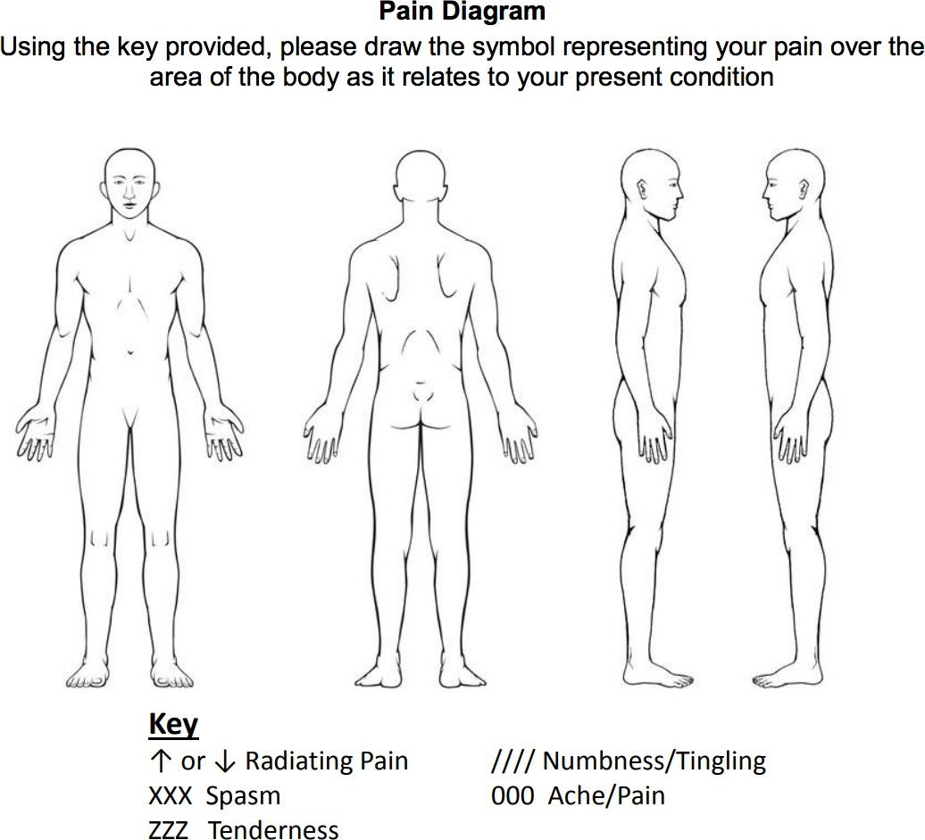

Rate Pain Intensity (0-10, 0 being no pain, 10 being worst pain possible)

/ /
Patient or Legal Guardian Signature Date

/ /
Therapist Signature Date

